InfluxDB 3.0 Python Client Documentation (GITHUB: <https://github.com/InfluxCommunity/influxdb3-python/blob/main/README.md>)

Youtube (<https://www.youtube.com/watch?v=tpdONTm1GC8>)

Template for influxdb (Library import, initialization, write, query)

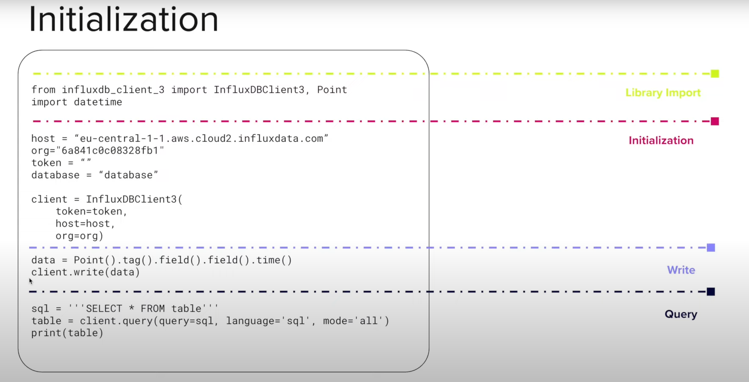

Sample write data to influxdb:

database="<BUCKET>"

data = {

"point1": {

"location": "Klamath",

"species": "bees",

"count": 23,

},

"point2": {

"location": "Portland",

"species": "ants",

"count": 30,

},

"point3": {

"location": "Klamath",

"species": "bees",

"count": 28,

},

"point4": {

"location": "Portland",

"species": "ants",

"count": 32,

},

"point5": {

"location": "Klamath",

"species": "bees",

"count": 29,

},

"point6": {

"location": "Portland",

"species": "ants",

"count": 40,

},

}

for key in data:

point = (

Point("census")

.tag("location", data[key]["location"])

.field(data[key]["species"], data[key]["count"])

)

client.write(database=database, record=point)

time.sleep(1) # separate points by 1 second

print("Complete. Return to the InfluxDB UI.")

Scenario on my end device

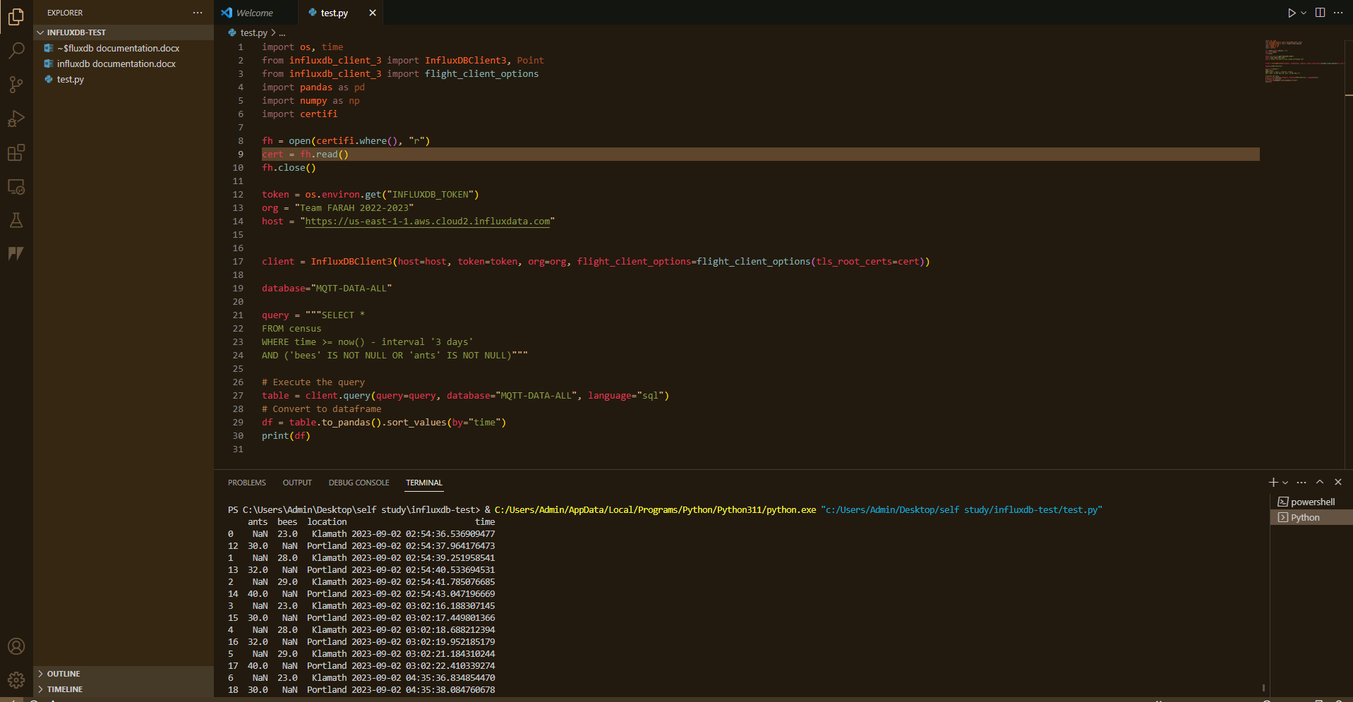

Problem scenario of windows os cannot locate root certificates to establish data exchanges with influxdb cloud.

As we query data in influxdb theres an error saying gRCP (Google Remote Procedure Call) cannot locate windows root certificate

So, we pip install certify and import the certify python library. The certifi package library provides a carefully curated collection of trusted authority certificates that our code can use to verify authenticity in connecting remote servers such as (influxdb)

After that, we create “fh” variable (file handle) and open the root certificate file using open() function.

Then variable “cert” reads the content of the root certificate file “fh” and save it. Cert now contains the text content of the root certificate.

Then fh.close() to close the file after we done get the content to free up system resources.